

**Project Report**

**Student Management System**

**Introduction to Database Management System**

**Group Members:**

* Adeel Khan
* Hassan Aslam
* Muween Iqbal
* Abeer Aijaz

**Teacher :** Miss Saira Yaseen

**Introduction**

Student Management System is a software which is helpful in Current Context for students as well as the Campus authorities. In the system where all the activities are done manually. It is very time consuming and costly to Manage your all resources within such System. Whereas .Our Student Management System deals with the various activities related to Student Management.

**This application is Form Based Application Built on Windows Application Form Using .Net Frame Work & C# language Plus SQL Server.**

**NET**is a software framework which is designed and developed by Microsoft.

The first version of the .Net framework was 1.0 which came in the year 2002. In easy words, it is a virtual machine for compiling and executing programs written in different languages like C#, VB.Net etc. It is used to develop Form-based applications, Web-based applications, and Web services. There is a variety of programming languages available on the .Net platform, VB.Net and **C#** being the most common ones. It is used to build applications for Windows, phone, web, etc. It provides a lot of functionalities and also supports industry standards.

There are mainly 2 modules in this software:

* Student module
* Faculty Module

**Features & Operations:**

* Student Management System Allows Registered Students to login in with their Credentials
* Student Management System Allows Registered Faculty to login in with their Credentials
* Student Can Check his/her Registered Courses after Successful Authentication
* Student Can Check his/her Makeup Classes Assigned by Faculty
* Student Can Check his/her Gpa & Total Marks in the Courses he/she is Registered
* Student can Check his Attendance Marked by Faculty.
* Whereas faculty can Add /Delete/ Update & Check Student Registered Courses.
* Faculty can Add /Delete/ Update & Check Makeup Classes
* Faculty can also manage Attendance for Registered Students
* Faculty can Also Add/Edit/Delete & Check Student Gpa & total marks through which Student Gpa is calculated.

**ERD:**

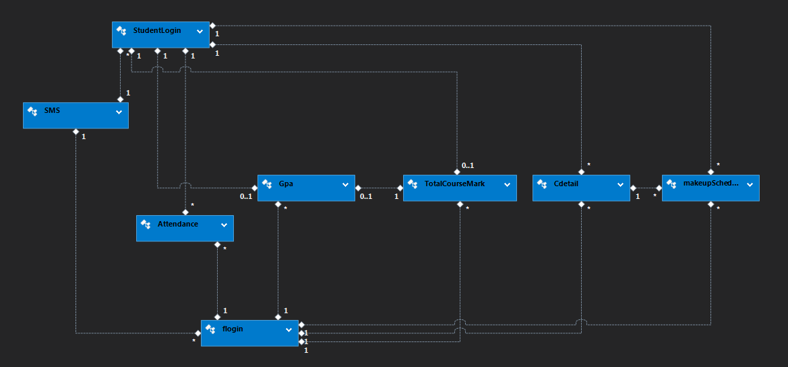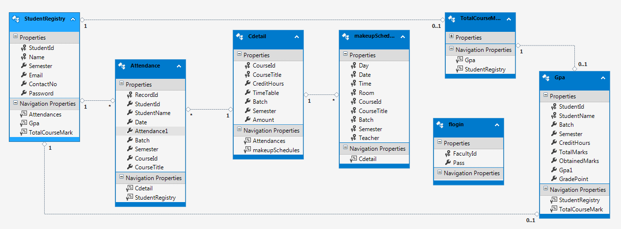

**Class Diagram**

**Holds the Class View of Student Management System All the Classes are enlisted in this Class Diagram Which are used in this Project.**

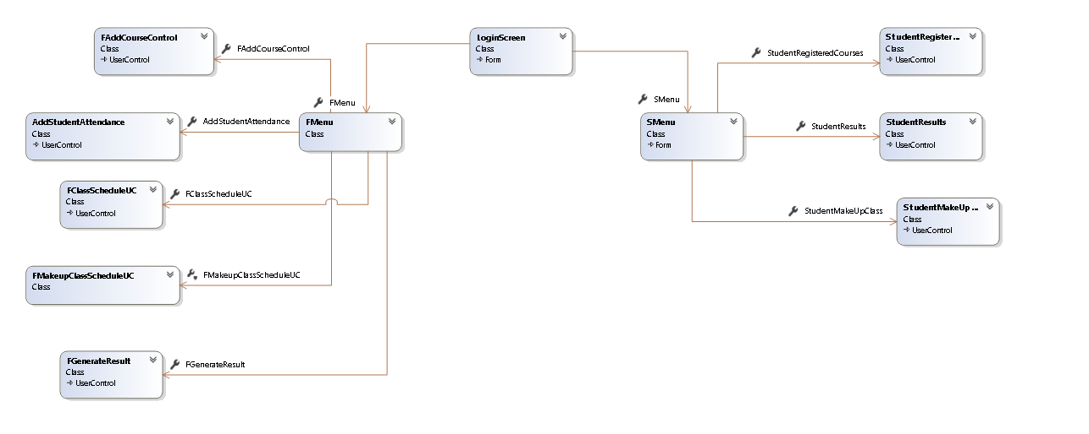

**Use Case Diagram:**

**Use Case Diagram of Student Management System which Represents the Scenario of this Project Based Application.**

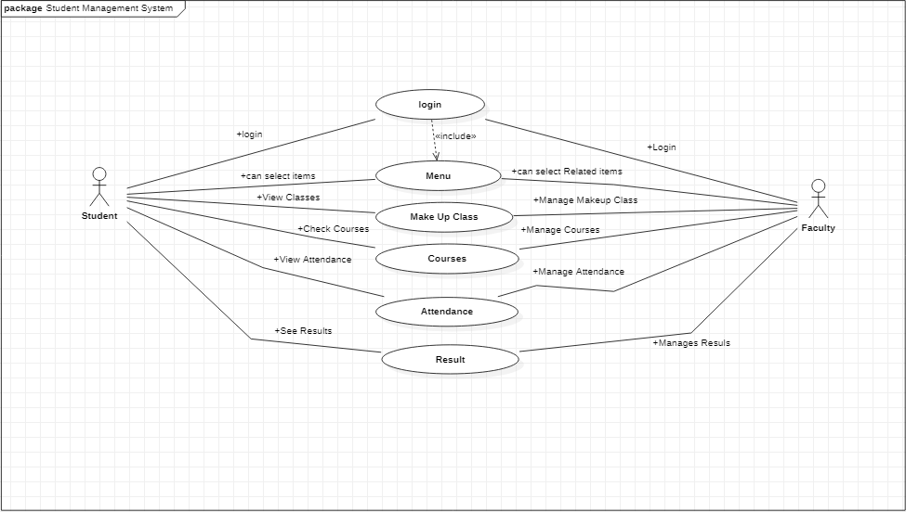

**Project Interface:**

**Student login**

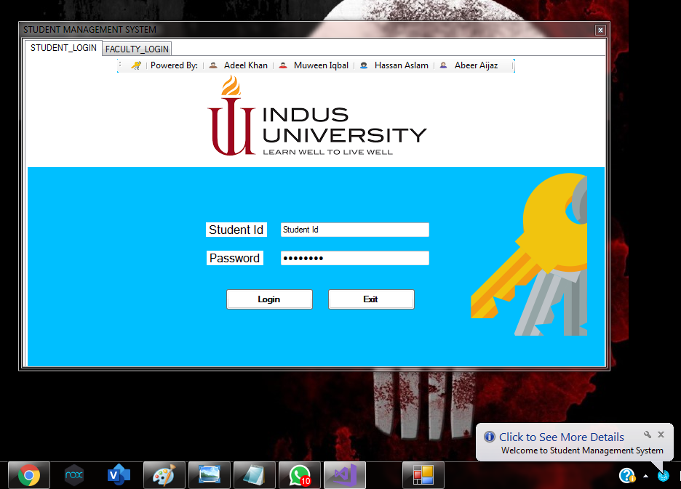

**Faculty Login**

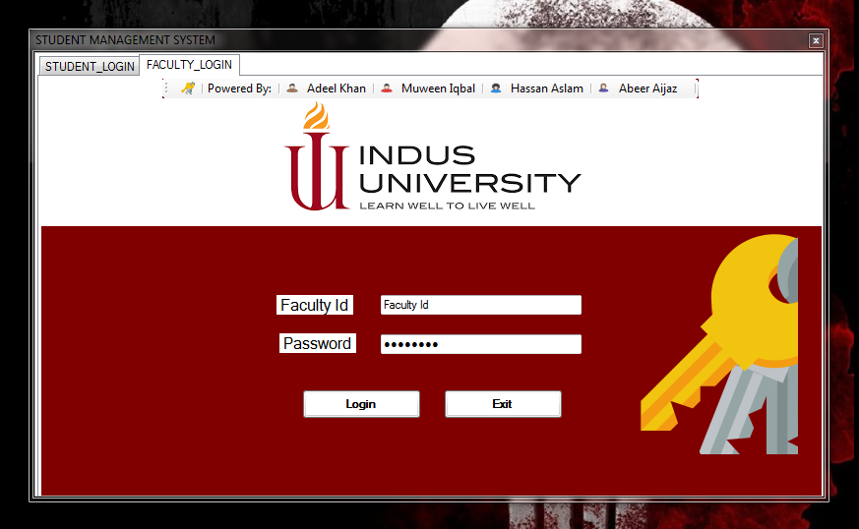

**Faculty View**

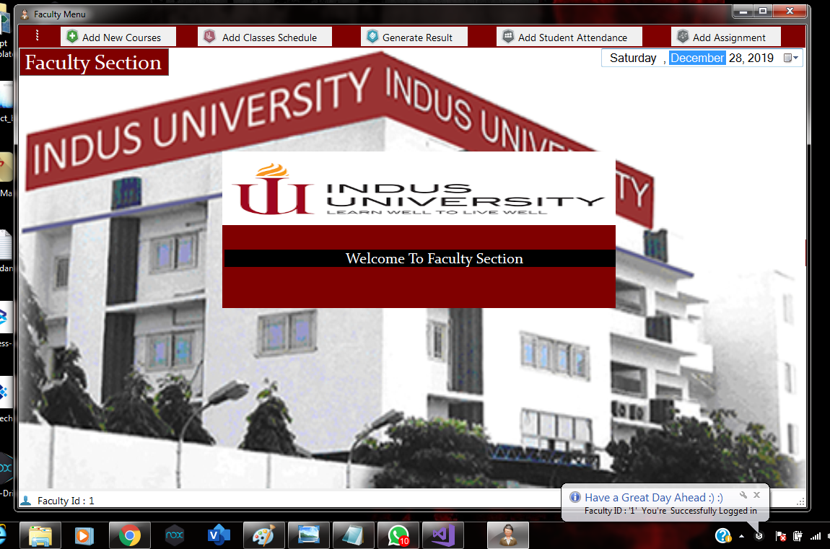

**Student View**

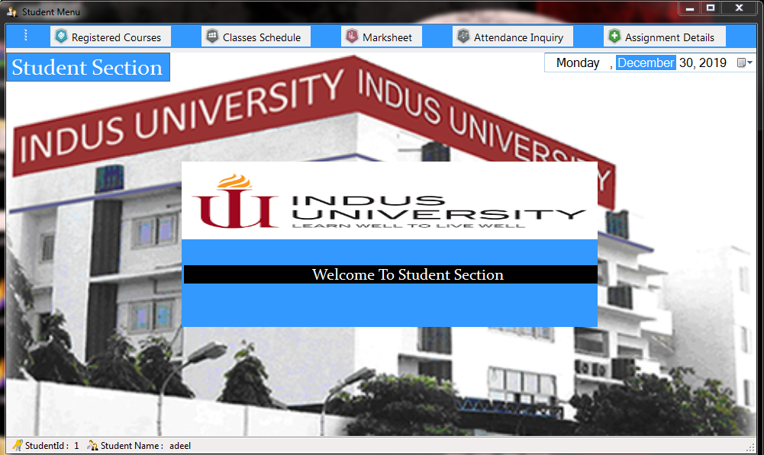

**Faculty : Add Student Attendance**

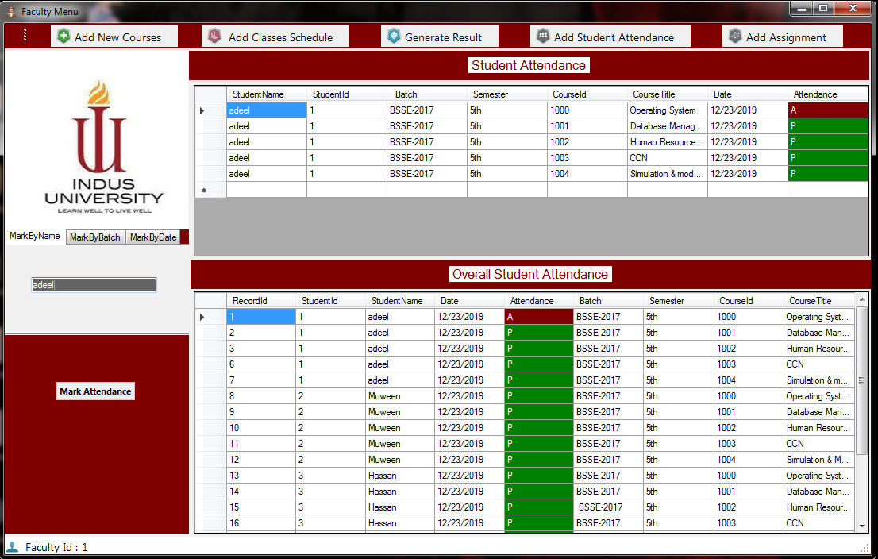

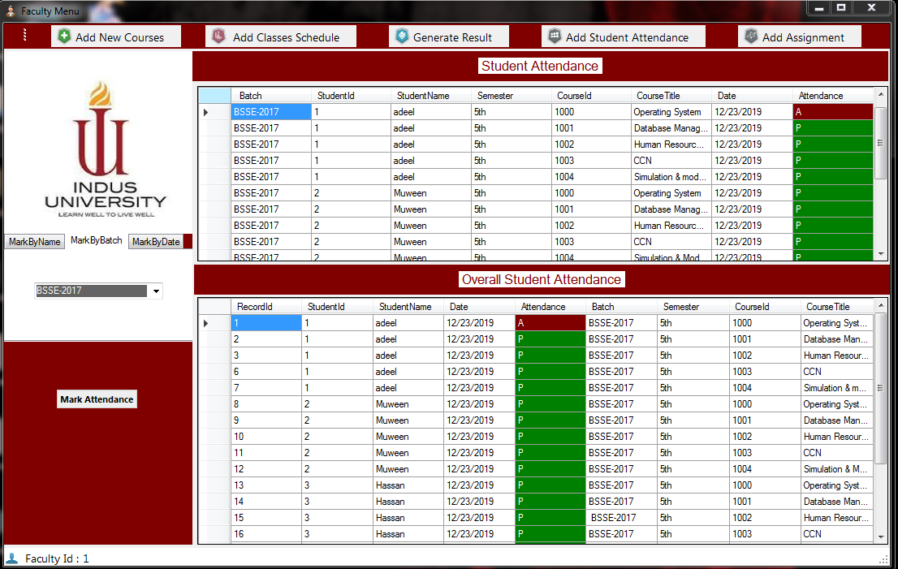

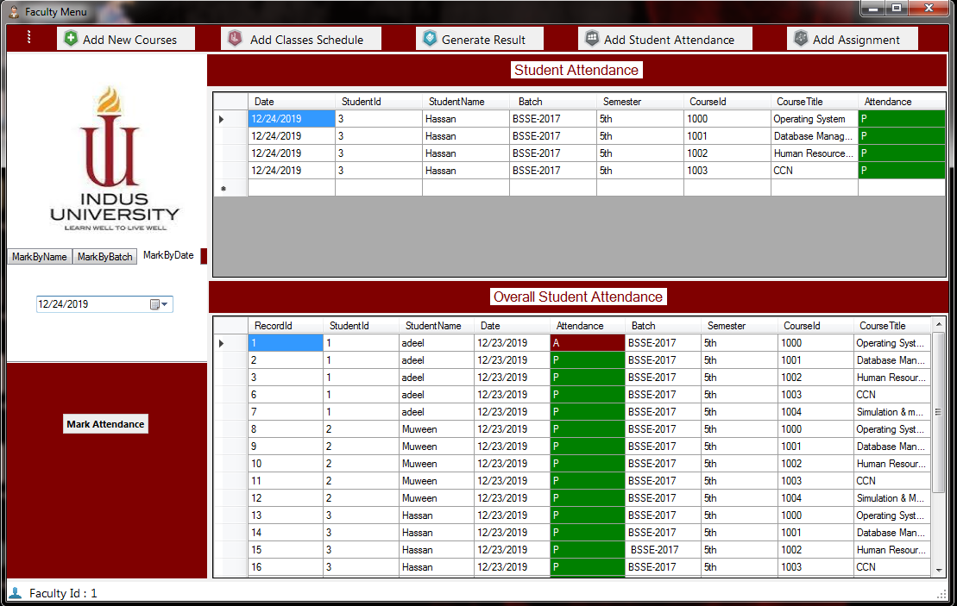

**Faculty Add Students Class Schedule**

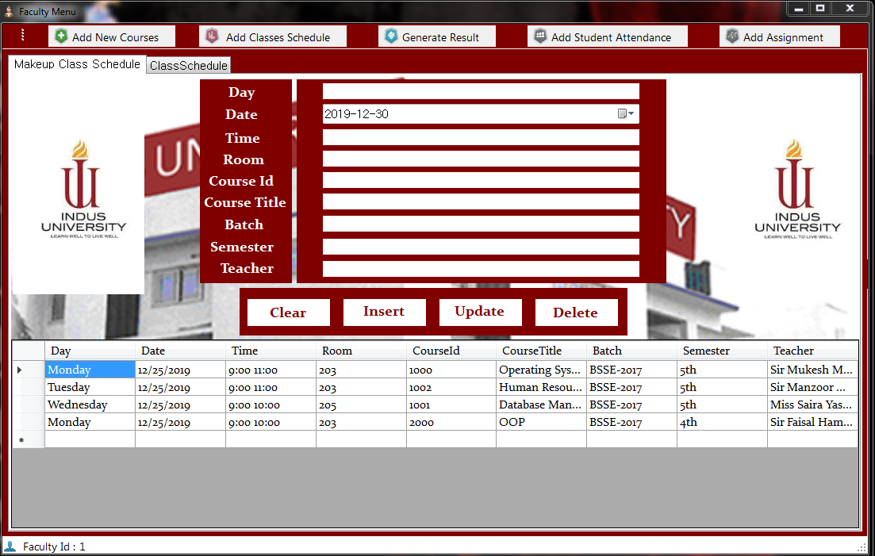

**Faculty: Add students Course**

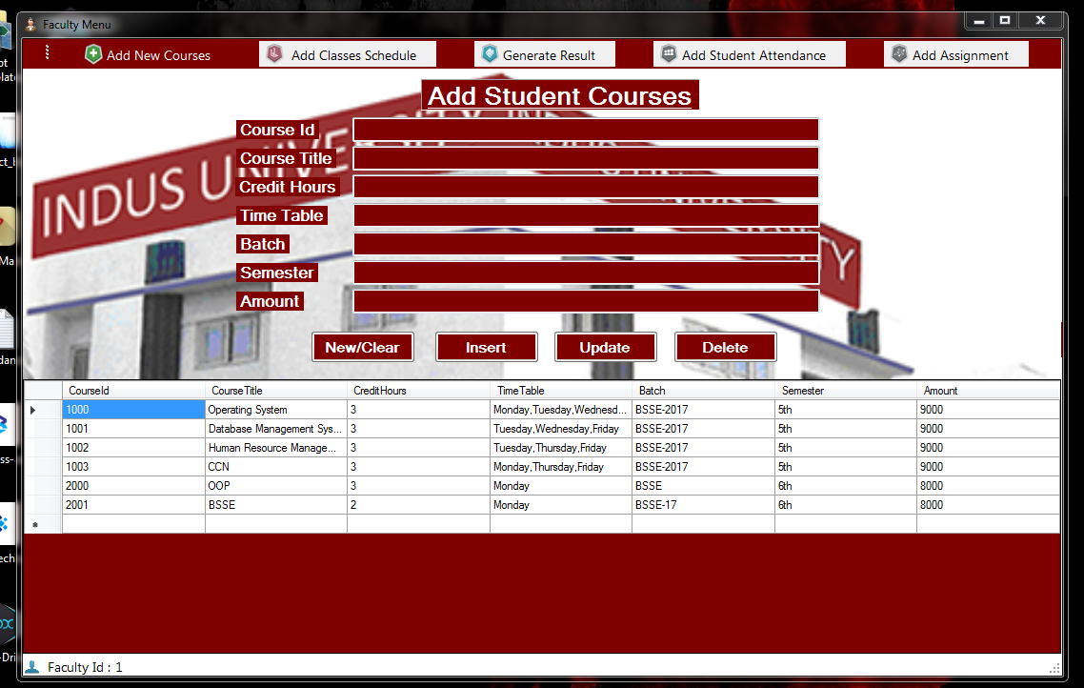

**Faculty Generate Results**

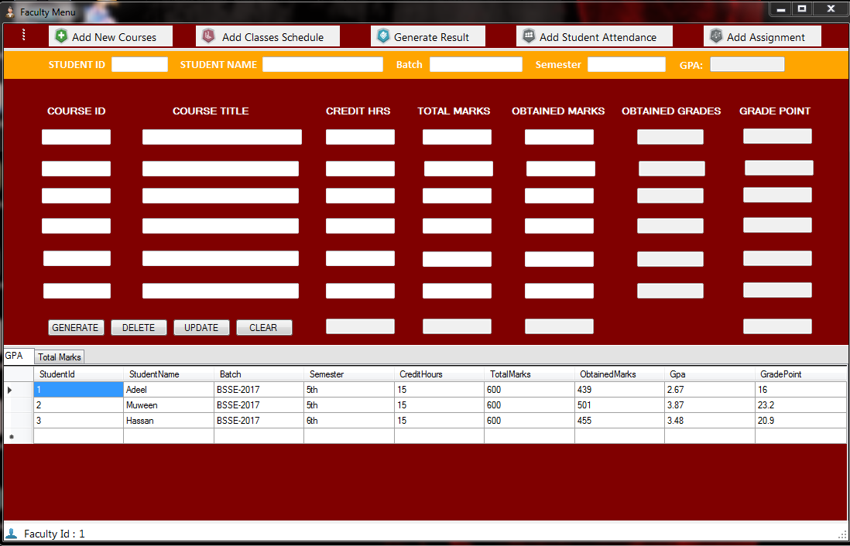

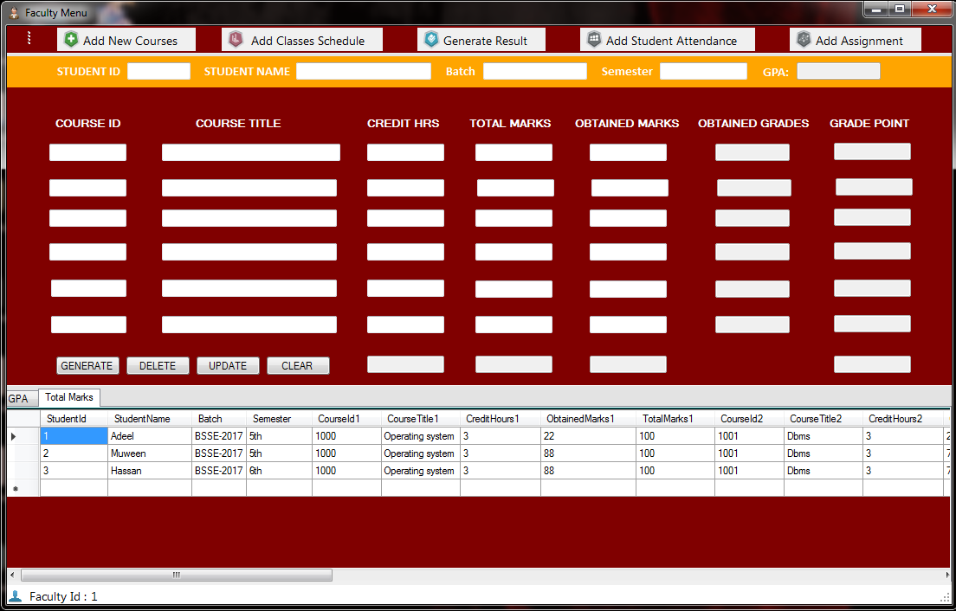

**Student makeup class**

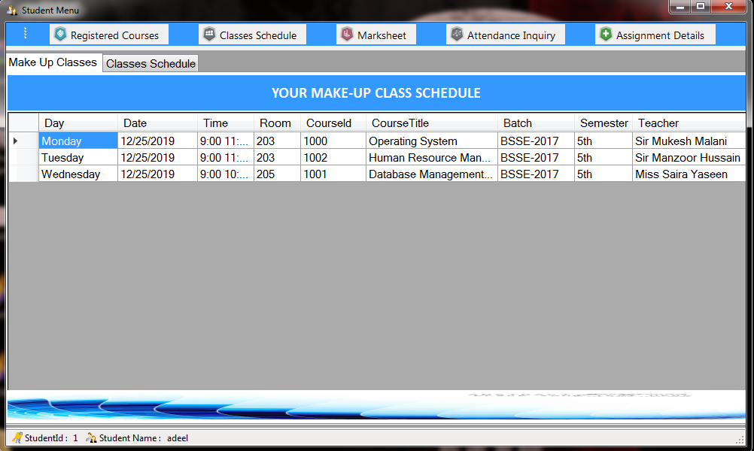

**Student Registered course**

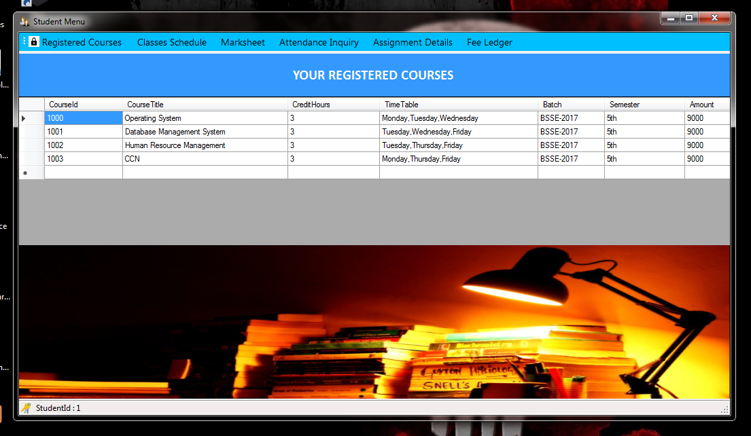

**Student Attendance Inquiry**

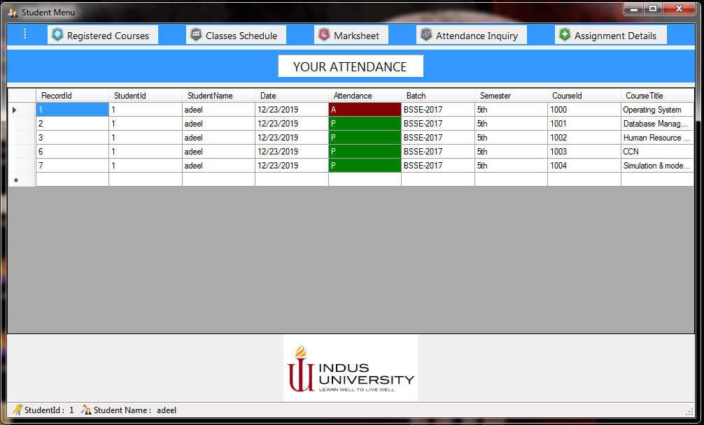

**Student Result**

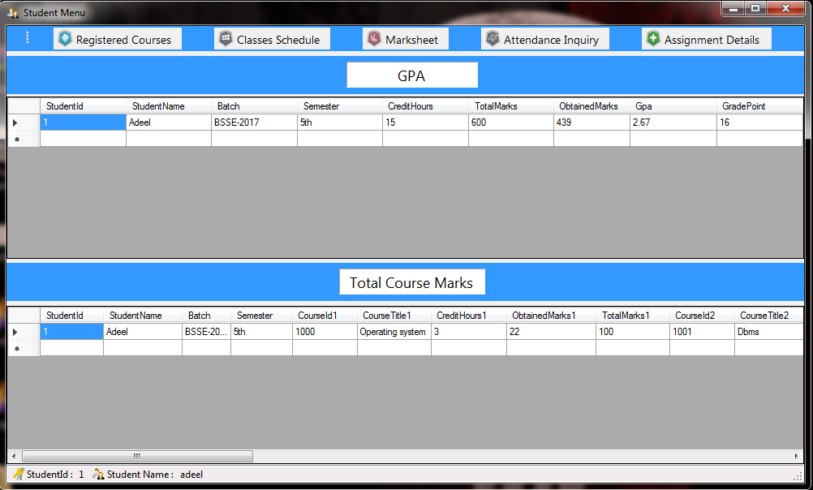

**References :**

* Icons downloaded from Icon Archive

[http://www.iconarchive.com/](http://www.iconarchive.com/%20)

* Some Content used In Introduction

<https://www.geeksforgeeks.org/introduction-to-net-framework/>

* Google used for Research

<https://www.google.com>